## Traffic Islands

**To create an island with the island tool:**

* Select the **Island** tool from the Infrastructure tab in the tools palette
* Start your island at the smallest corner, click once to start drawing
* Move in either a clockwise, or anti-clockwise order, clicking at each of your island’s corner points (**Note**: Remember, you can hold **SHIFT** to keep the corners of your island perfectly straight)
* When you have placed your last point, right click to stop drawing, and then right click to drop the Island tool
* 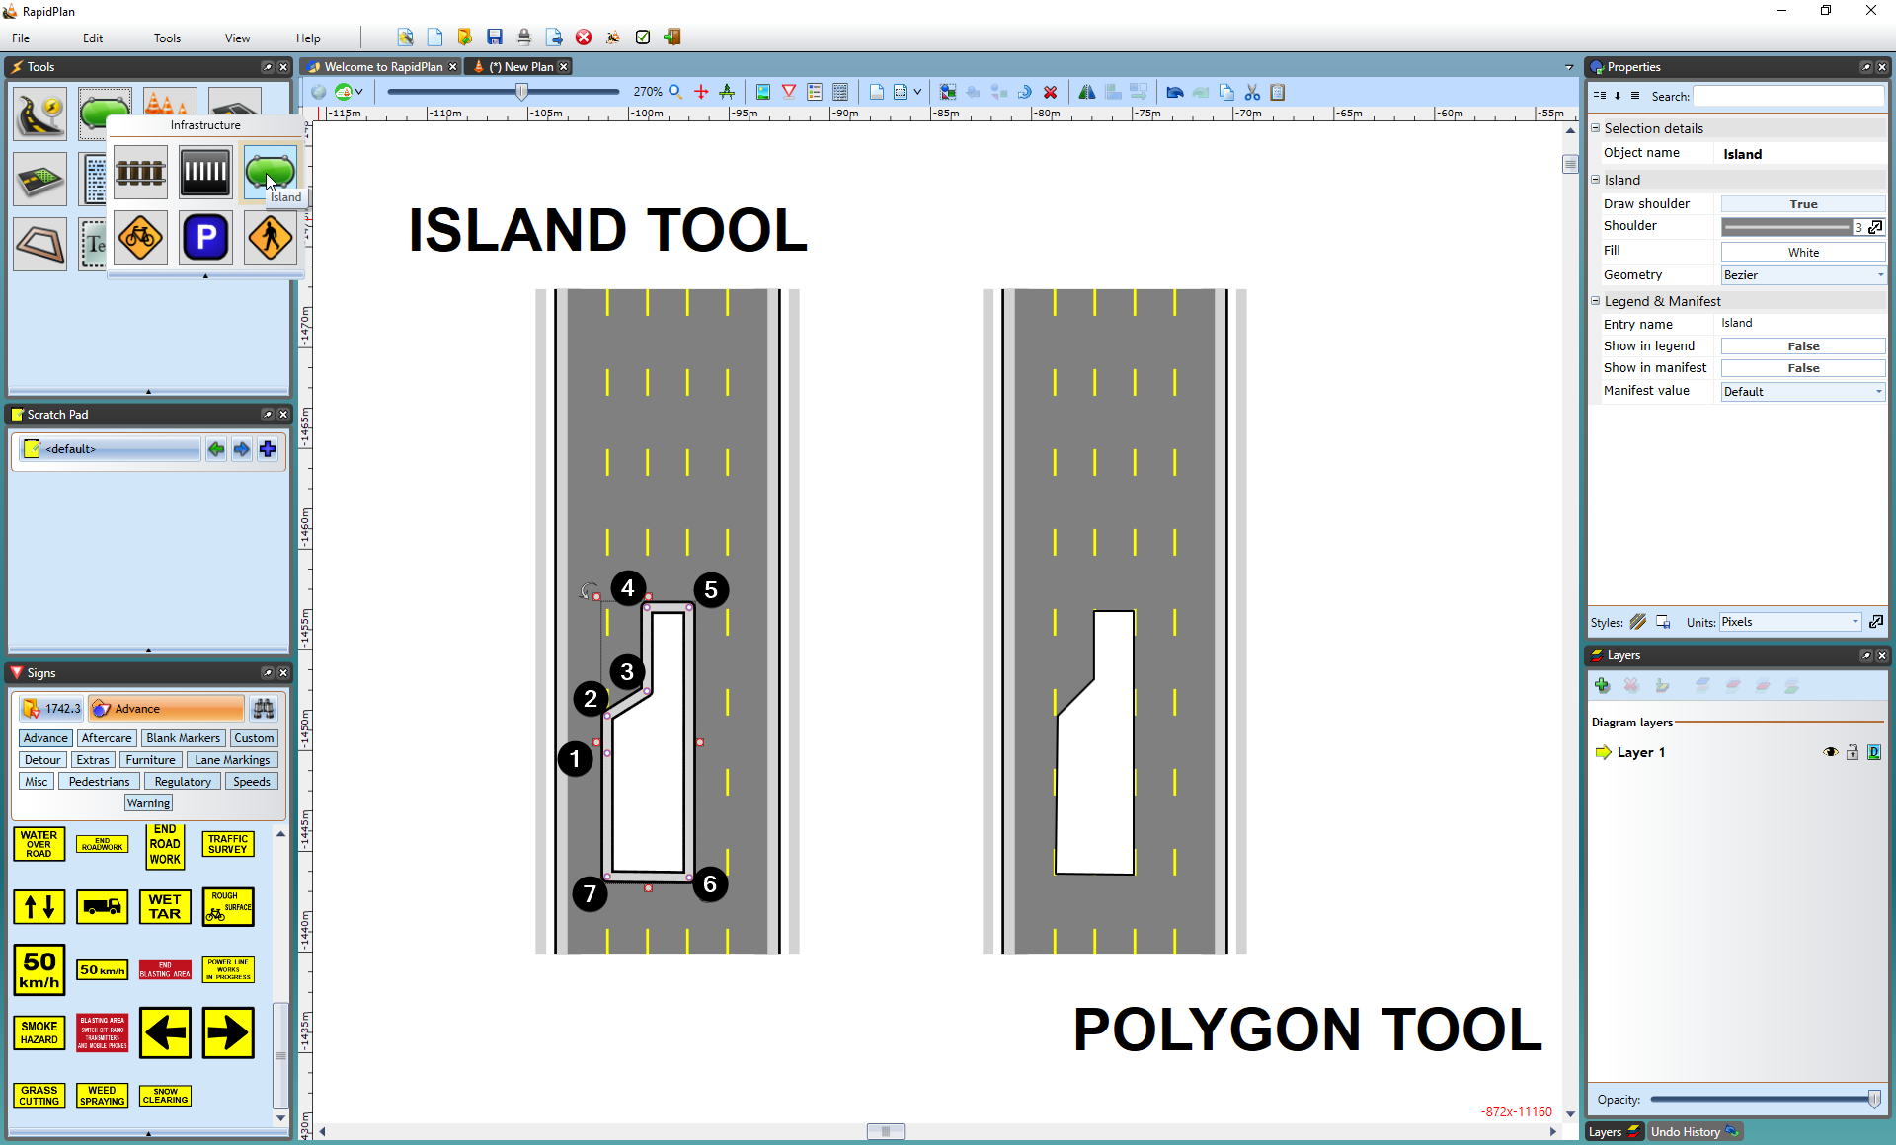
* The_Island_Tool_verses_Polygon_Tool

There are two main differences between using the polygon and Island tool:

**Note that you should never start your island on a steep corner point (anything greater than about 45 degrees). This is because it can cause the shoulder lines to cross over.**

The technique for creating control points is simple but requires some practice.

**To create a curved island:**

* Draw your island as normal
* Ensure your cursor is clear of the Island Tool by right clicking
* Now select the Island that you’ve drawn by clicking on it once
* Move your cursor over the control point that you wish to curve and hold down the **CTRL** button on the keyboard. The control points will then turn from red to blue and display curve handles
* Drag the curve handles out (away from the control point) to increase the radius of the curve until you are happy with the islands shape
* 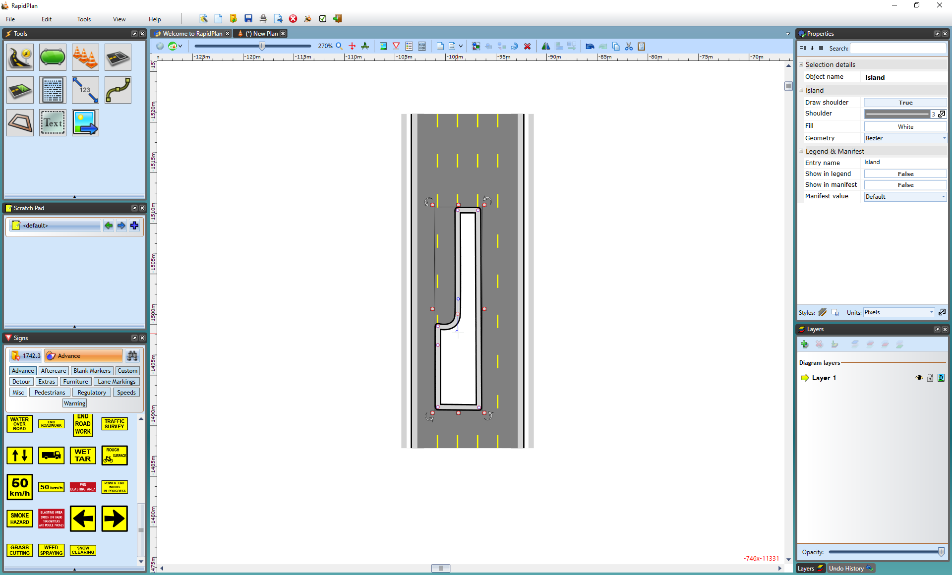
* Curving_Island